CPSC 332 Database Project

**Group members:**

|  |  |
| --- | --- |
| **Name** | **Last 4 CWID** |
| Nayeli ****** | **** |
| Hiep **** | **** |
| Poleth **** | **** |

**Submission Account:** cs332t31

**Website:** http://ecs.fullerton.edu/~cs332t31/

**Entity-Relationship Model:**

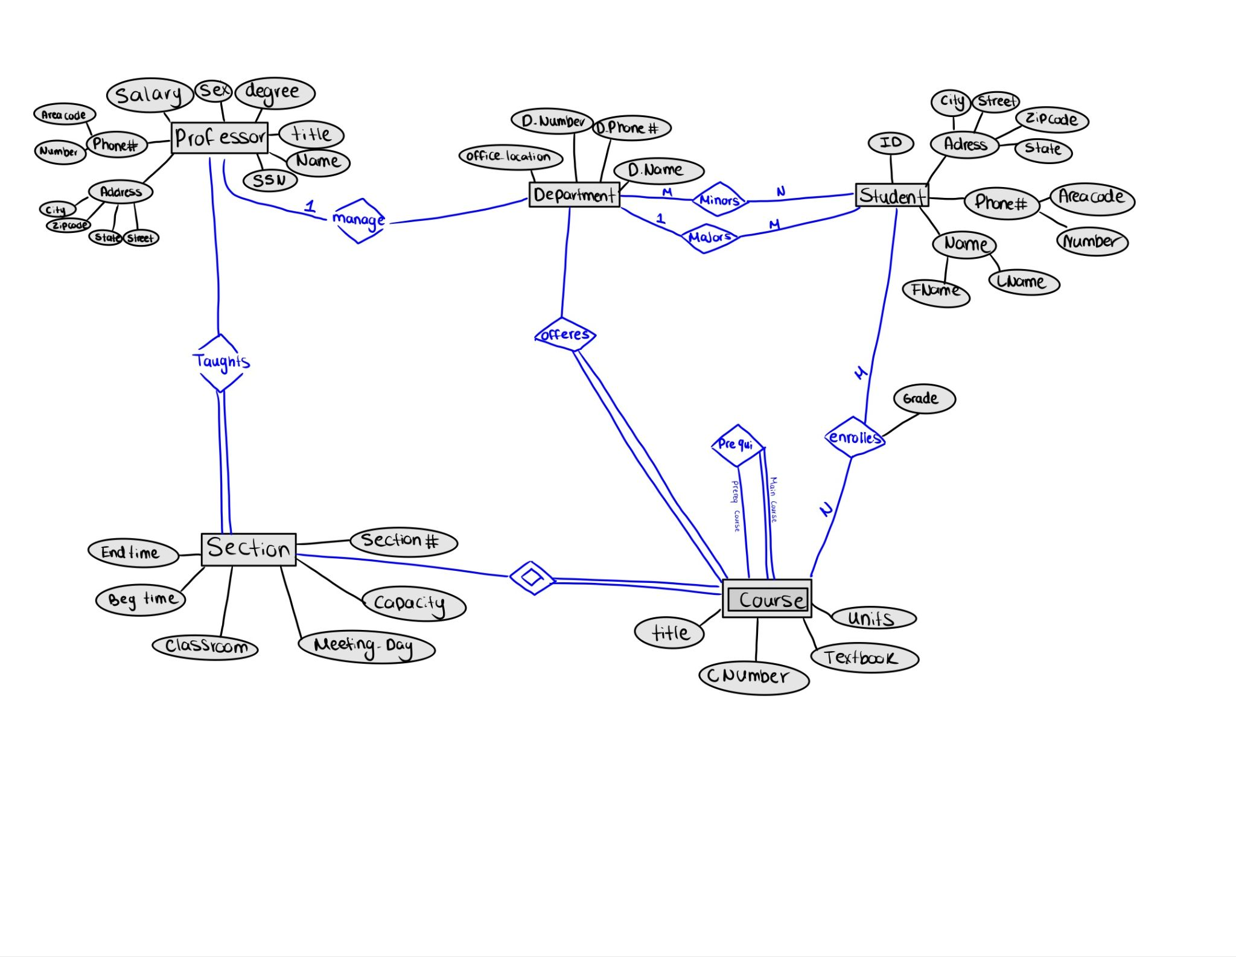

**Relational Model:**

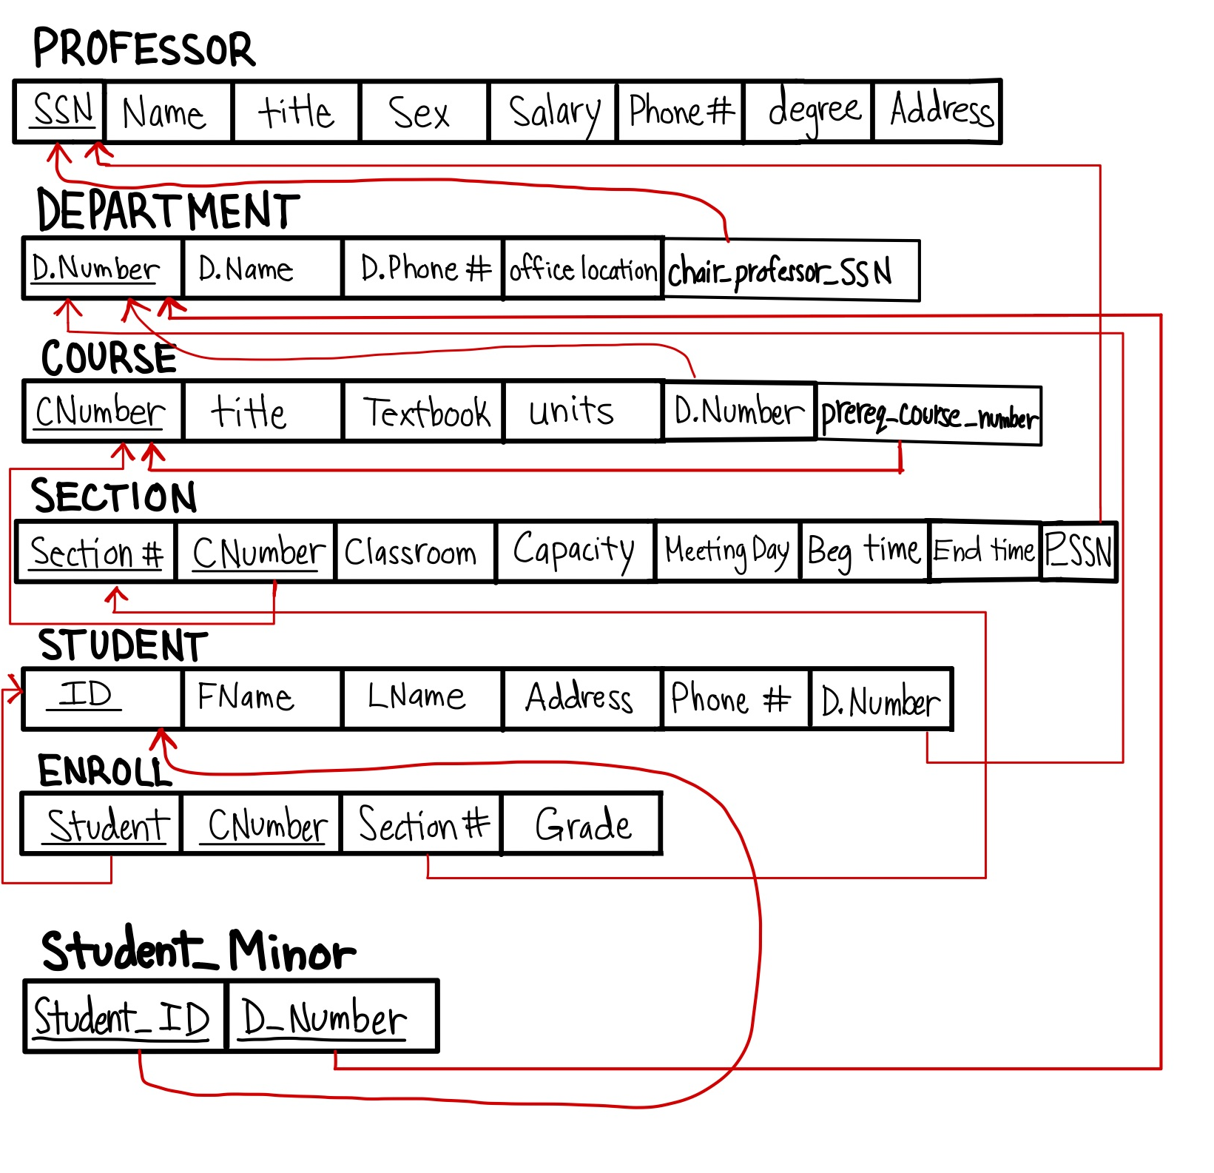

**Primary keys:**

Professor (SSN)

Department (D.Number)

Course (CNumber)

Section (Section#, CNumber)

Student (ID)

Enroll (Student, CNumber)

**Foreign keys:**

Department (Professor) REFERENCES Section (Section#, CNumber)

Course (D.Number) REFERENCES Department (D.Number)

Section (CNumber) REFERENCES Course (CNumber)

Section (P_SSN) REFERENCES Professor (SSN)

Student (D.Number) REFERENCES Department (D.Number)

Enroll (Student) REFERENCES Student (ID)

Enroll (Section#) REFERENCES Section (Section#)

Student_Minor (Student_ID) REFERENCES Student (ID)

Student_Minor (D_Number) REFERENCES Department (D.Number)

**SQL DDL:**

CREATE TABLE Department (

D_Number VARCHAR(10) PRIMARY KEY,

D_Name VARCHAR(50),

D_Phone VARCHAR(20),

Office_Location VARCHAR(50)

);

ALTER TABLE Department

ADD COLUMN Chairperson_Professor_SSN VARCHAR(14),

ADD CONSTRAINT fk_Chairperson_Professor_SSN

FOREIGN KEY (Chairperson_Professor_SSN)

REFERENCES Professor (SSN);

CREATE TABLE Professor (

SSN VARCHAR(14) NOT NULL PRIMARY KEY,

Name VARCHAR(50) NOT NULL,

Title VARCHAR(50),

Sex CHAR(1),

Salary DECIMAL(10,2),

Phone VARCHAR(20),

Degree VARCHAR(50),

Address VARCHAR(100)

);

CREATE TABLE Course (

C_Number VARCHAR(10) NOT NULL PRIMARY KEY,

Title VARCHAR(255) NOT NULL,

Textbook VARCHAR(255),

Units INT,

D_Number VARCHAR(10) NOT NULL,

Prerequisite_Course_Number VARCHAR(10),

FOREIGN KEY (D_Number) REFERENCES Department (D_Number),

FOREIGN KEY (Prerequisite_Course_Number) REFERENCES Course (C_Number)

);

CREATE TABLE Section (

S_Number VARCHAR(15) NOT NULL,

C_Number VARCHAR(10) NOT NULL,

Classroom VARCHAR(50),

Capacity INT,

Meeting_Day VARCHAR(10),

Beginning_Time TIME,

End_Time TIME,

PRIMARY KEY (S_Number, C_Number),

FOREIGN KEY (C_Number) REFERENCES Course(C_Number)

);

ALTER TABLE Section

ADD COLUMN P_SSN CHAR(11),

ADD CONSTRAINT FK_Section_Professor

FOREIGN KEY (P_SSN)

REFERENCES Professor(SSN);

CREATE TABLE Student (

ID VARCHAR(10) NOT NULL PRIMARY KEY,

Fname VARCHAR(50) NOT NULL,

Lname VARCHAR(50) NOT NULL,

Address VARCHAR(100),

Phone VARCHAR(20),

D_Number VARCHAR(10) NOT NULL,

FOREIGN KEY (D_Number) REFERENCES Department(D_Number)

);

CREATE TABLE Student_Minor (

Student_ID VARCHAR(10) NOT NULL,

Department_Number VARCHAR(10) NOT NULL,

PRIMARY KEY (Student_ID, Department_Number),

FOREIGN KEY (Student_ID) REFERENCES Student(ID),

FOREIGN KEY (Department_Number) REFERENCES Department(D_Number)

);

CREATE TABLE Enroll (

Student VARCHAR(10) NOT NULL,

C_Number VARCHAR(10) NOT NULL,

S_Number VARCHAR(15) NOT NULL,

Grade VARCHAR(2),

PRIMARY KEY (Student, C_Number),

FOREIGN KEY (Student) REFERENCES Student(ID),

FOREIGN KEY (C_Number) REFERENCES Course(C_Number),

FOREIGN KEY (S_Number) REFERENCES Section(S_Number)

);

**SQL Queries:**

INSERT INTO Department (D_Number, D_Name, D_Phone, Office_Location, Chairperson_Professor_SSN)

VALUES

('CPSC', 'Computer Science', '657-278-3163', 'Computer Science Building, Room 202', '123-45-6789'),

('ENGL', 'English', '657-278-3163', 'Gordon Halls, Room 323B', '345-67-8901'),

('MATH', 'Mathematics', '657-278-3163', 'McCarthy Hall, Room 154', '234-56-7890');

INSERT INTO Professor (SSN, Name, Title, Sex, Salary, Phone, Degree, Address)

VALUES

('123-45-6789', 'Bernie Howell', 'Assistant Professor', 'M', 80000, '1-714-774-7821', 'PhD', '123 Main St CA 92702'),

('234-56-7890', 'Lisa Schaefer', 'Professor', 'F', 100000, '1-714-772-3485', 'PhD', '456 South West St CA 92865'),

('345-67-8901', 'Renato Archer', 'Professor', 'M', 120000, '1-714-819-2304', 'PhD', '789 Oakland St CA 92843');

INSERT INTO Course (C_Number, Title, Textbook, Units, D_Number, Prerequesite_Course_Number)

VALUES

('CPSC 121', 'Introduction to Computer Science', 'Starting Out with C++', 3, 'CPSC', NULL),

('CPSC 131', 'Data Structures and Programming Techniques', 'Data Structures and Algorithms in C++', 3, 'CPSC', 'CPSC 121'),

('ENGL 101', 'Composition and Rhetoric', 'The Norton Field Guide to Writing', 3, 'ENGL', NULL),

('MATH 150A', 'Calculus I', 'Calculus: Early Transcendentals', 4, NULL);

INSERT INTO Section (S_Number, C_Number, Classroom, Capacity, Meeting_Day, Beginning_Time, End_Time) VALUES

('Section 01', 'CPSC 121', 'CS Building, Room 201', 30, 'MWF', '09:00:00', '09:50:00'),

('Section 02', 'CPSC 121', 'CS Building, Room 332', 25, 'TTH', '11:00:00', '12:20:00'),

('Section 01', 'CPSC 131', 'CS Building, Room 201', 40, 'MW', '01:00:00', '02:20:00'),

('Section 02', 'CPSC 131', 'CS Building, Room 605', 20, 'TTH', '03:30:00', '04:50:00'),

('Section 01', 'ENGL 101', 'Gordon Halls, Room 202', 35, 'MWF', '11:00:00', '11:50:00'),

('Section 01', 'MATH 150A', 'McCarthy Hall, Room 601', 30, 'TTH', '10:00:00', '11:20:00');

UPDATE Section

SET P_SSN = '123-45-6789'

WHERE S_Number = 'Section 01' AND C_Number = 'CPSC 121';

UPDATE Section

SET P_SSN = '123-45-6789'

WHERE S_Number = 'Section 02' AND C_Number = 'CPSC 121';

UPDATE Section

SET P_SSN = '123-45-6789'

WHERE S_Number = 'Section 01' AND C_Number = 'CPSC 131';

UPDATE Section

SET P_SSN = '123-45-6789'

WHERE S_Number = 'Section 02' AND C_Number = 'CPSC 131';

UPDATE Section

SET P_SSN = '345-67-8901'

WHERE S_Number = 'Section 01' AND C_Number = 'ENGL 101';

UPDATE Section

SET P_SSN = '234-56-7890'

WHERE S_Number = 'Section 01' AND C_Number = 'MATH 150A';

INSERT INTO Student (ID, Fname, Lname, Address, Phone, D_Number)

VALUES

('103749882', 'Donny', 'Vazquez', '1232 Maryland St', '714-555-1212', 'CPSC'),

('932233223', 'Samuel', 'Patton', '4567 N. Hamilton St', '714-555-2121', 'CPSC'),

('123358250', 'Hazel', 'Merritt', '7890 Oakland St', '714-555-3434', 'CPSC'),

('796862879', 'Alice', 'Williams', '3213 Maple St', '714-555-4545', 'CPSC'),

('997342361', 'David', 'Lee', '987 North Cherry Drive St', '714-555-5656', 'ENGL'),

('339862886', 'Mary', 'Jones', '654 Lincoln St', '714-555-6767', 'ENGL'),

('736974249', 'Mark', 'Davis', '876 Cheddar Ave', '714-555-7878', 'MATH'),

('414101389', 'Karen', 'Taylor', '5434 South Birch St', '714-555-8989', 'MATH');

INSERT INTO Enroll (Student, C_Number, S_Number, Grade)

VALUES

('103749882', 'CPSC 121', 'Section 01', 'B'),

('932233223', 'CPSC 131', 'Section 01', 'A-'),

('123358250', 'ENGL 101', 'Section 01', 'C'),

('796862879', 'MATH 150A', 'Section 02', 'D+'),

('997342361', 'CPSC 121', 'Section 02', 'B-'),

('339862886', 'CPSC 131', 'Section 02', 'C+'),

('736974249', 'ENGL 101', 'Section 02', 'A'),

('414101389', 'MATH 150A', 'Section 01', 'C-'),

('103749882', 'ENGL 101', 'Section 01', 'B+'),

('932233223', 'MATH 150A', 'Section 01', 'D-'),

('123358250', 'CPSC 121', 'Section 02', 'F'),

('796862879', 'CPSC 131', 'Section 02', 'C'),

('997342361', 'ENGL 101', 'Section 02', 'A-'),

('339862886', 'MATH 150A', 'Section 02', 'B+'),

('736974249', 'CPSC 121', 'Section 01', 'B-'),

('414101389', 'CPSC 131', 'Section 01', 'D'),

('103749882', 'MATH 150A', 'Section 02', 'C+'),

('932233223', 'ENGL 101', 'Section 02', 'A'),

('123358250', 'CPSC 131', 'Section 01', 'B'),

('736974249', 'MATH 150A', 'Section 01', 'C-');

**Web Interface & PHP Code:**

1. **index.php**

**<html>**

**<head>**

**<title>Database Project</title>**

**<style>**

**h1 {**

**font-size: 3em;**

**color: #333;**

**text-align: center;**

**margin-top: 50px;**

**margin-bottom: 50px;**

**}**

**</style>**

**</head>**

**<body>**

**<form method="POST">**

**<h1>Welcome to Our Web Application Database Project</h1>**

**<label for="user_type">Are you a professor or a student?</label>**

**<select name="user_type" id="user_type">**

**<option value="professor">Professor</option>**

**<option value="student">Student</option>**

**</select>**

**<input type="submit" value="Submit">**

**</form>**

**</body>**

**</html>**

**<?php**

**if ($_SERVER["REQUEST_METHOD"] == "POST") {**

**$user_type = $_POST["user_type"];**

**if ($user_type == "professor") {**

**header("Location: professor.php");**

**exit();**

**} elseif ($user_type == "student") {**

**header("Location: student.php");**

**exit();**

**}**

**}**

**?>**

1. **student.php**

**<html>**

**<head>**

**<title>Database Project</title>**

**<style>**

**h1 {**

**font-size: 3em;**

**color: #333;**

**text-align: center;**

**margin-top: 50px;**

**margin-bottom: 50px;**

**}**

**table {**

**border-collapse: collapse;**

**width: 100%;**

**}**

**th,**

**td {**

**padding: 8px;**

**text-align: left;**

**border-bottom: 1px solid #ddd;**

**}**

**th {**

**background-color: #4CAF50;**

**color: white;**

**}**

**tr:nth-child(even) {**

**background-color: #f2f2f2;**

**}**

**</style>**

**</head>**

**<body>**

**<form method="GET">**

**<h1>Welcome to Our Web Application Database Project</h1>**

**<label for="search_course">Enter Course Number:</label>**

**<input type="text" id="search_course" name="search_course">**

**<input type="submit" value="Submit">**

**<input type="button" value="Clear current query" onclick="location.href='student.php';">**

**<input type="button" value="Return to homepage" onclick="location.href='index.php';">**

**</form>**

**<form method="GET">**

**<label for="cw_id">Enter Student CWID:</label>**

**<input type="text" id="cw_id" name="cw_id">**

**<input type="submit" value="Submit">**

**<input type="button" value="Clear current query" onclick="location.href='student.php';">**

**<input type="button" value="Return to homepage" onclick="location.href='index.php';">**

**</form>**

**<?php**

**// username and password need to be replaced by your username and password**

**// dbname is the same as your username**

**$link = mysqli_connect('mariadb', 'cs332t9', 'br79JFW4', 'cs332t9');**

**if (!$link) {**

**die('Could not connect: ' . mysql_error());**

**}**

**echo 'Database loaded successfully.<p>';**

**// Course sections query**

**if (isset($_GET['search_course'])) {**

**$search_course = mysqli_real_escape_string($link, $_GET['search_course']);**

**$section_query = "SELECT Section.S_Number, Section.Classroom, Section.Meeting_day, Section.Beginning_time, Section.End_time, COUNT(*) AS Enrollment FROM Section INNER JOIN Enroll ON Section.S_Number = Enroll.S_Number AND Section.C_Number = Enroll.C_Number WHERE Section.C_Number = '$search_course' GROUP BY Section.S_Number";**

**$section_result = $link->query($section_query);**

**if ($section_result->num_rows > 0) {**

**echo "<table>";**

**echo "<tr><th>Section</th><th>Classroom</th><th>Meeting Day</th><th>Time</th><th>Enrollment</th></tr>";**

**while ($row = $section_result->fetch_assoc()) {**

**echo "<tr>";**

**echo "<td>".$row["S_Number"]."</td>";**

**echo "<td>".$row["Classroom"]."</td>";**

**echo "<td>".$row["Meeting_day"]."</td>";**

**echo "<td>".$row["Beginning_time"]." - ".$row["End_time"]."</td>";**

**echo "<td>".$row["Enrollment"]."</td>";**

**echo "</tr>";**

**}**

**echo "</table>";**

**} else {**

**echo "No results found.";**

**}**

**$section_result->free_result();**

**}**

**// Check for a submitted CWID**

**if (isset($_GET['cw_id'])) {**

**$cwid = mysqli_real_escape_string($link, $_GET['cw_id']);**

**// Query the database for the student's courses and grades**

**$query = "SELECT Course.C_Number, Course.Title, Enroll.Grade**

**FROM Enroll**

**INNER JOIN Course ON Enroll.C_Number = Course.C_Number**

**WHERE Enroll.Student = '$cwid'";**

**$result = mysqli_query($link, $query);**

**// Display the results in a table**

**if (mysqli_num_rows($result) > 0) {**

**echo "<table>";**

**echo "<tr><th>Course Number</th><th>Course Title</th><th>Grade</th></tr>";**

**while ($row = mysqli_fetch_assoc($result)) {**

**echo "<tr>";**

**echo "<td>".$row["C_Number"]."</td>";**

**echo "<td>".$row["Title"]."</td>";**

**echo "<td>".$row["Grade"]."</td>";**

**echo "</tr>";**

**}**

**echo "</table>";**

**} else {**

**echo "No results found.";**

**}**

**// Free the result set**

**mysqli_free_result($result);**

**}**

**$link->close();**

**?>**

**</body>**

**</html>**

1. **professor.php**

**<html>**

**<head>**

**<title>Database Project</title>**

**<style>**

**h1 {**

**font-size: 3em;**

**color: #333;**

**text-align: center;**

**margin-top: 50px;**

**margin-bottom: 50px;**

**}**

**table {**

**border-collapse: collapse;**

**width: 100%;**

**}**

**th,**

**td {**

**padding: 8px;**

**text-align: left;**

**border-bottom: 1px solid #ddd;**

**}**

**th {**

**background-color: #4CAF50;**

**color: white;**

**}**

**tr:nth-child(even) {**

**background-color: #f2f2f2;**

**}**

**</style>**

**</head>**

**<body>**

**<form method="GET">**

**<h1>Welcome to Our Web Application Database Project</h1>**

**<label for="search_ssn">Enter Professor SSN:</label>**

**<input type="text" id="search_ssn" name="search_ssn">**

**<input type="submit" value="Submit">**

**<input type="button" value="Clear current query" onclick="location.href='professor.php';">**

**<input type="button" value="Return to homepage" onclick="location.href='index.php';">**

**</form>**

**<form method="GET">**

**<label for="search_course">Enter Course Number:</label>**

**<input type="text" id="search_course" name="search_course">**

**<label for="search_section">Enter Section Number:</label>**

**<input type="text" id="search_section" name="search_section">**

**<input type="submit" value="Submit">**

**<input type="button" value="Clear current query" onclick="location.href='professor.php';">**

**<input type="button" value="Return to homepage" onclick="location.href='index.php';">**

**</form>**

**<?php**

**// username and password need to be replaced by your username and password**

**// dbname is the same as your username**

**$link = mysqli_connect('mariadb', 'cs332t9', 'br79JFW4', 'cs332t9');**

**if (!$link) {**

**die('Could not connect: ' . mysql_error());**

**}**

**echo 'Database loaded successfully.<p>';**

**//Professor SSN query**

**if (isset($_GET['search_ssn'])) {**

**$search_ssn = mysqli_real_escape_string($link, $_GET['search_ssn']);**

**$prof_query = "SELECT S_Number, C_Number, Classroom, Meeting_day, Beginning_time, End_time FROM Section WHERE P_SSN = '$search_ssn'";**

**$prof_result = $link->query($prof_query);**

**if ($prof_result->num_rows > 0) {**

**echo "<table>";**

**echo "<tr><th>Section</th><th>Course Name</th><th>Classroom</th><th>Meeting Day</th><th>Time</th></tr>";**

**while ($row = $prof_result->fetch_assoc()) {**

**echo "<tr>";**

**echo "<td>".$row["S_Number"]."</td>";**

**echo "<td>".$row["C_Number"]."</td>";**

**echo "<td>".$row["Classroom"]."</td>";**

**echo "<td>".$row["Meeting_day"]."</td>";**

**echo "<td>".$row["Beginning_time"]." - ".$row["End_time"]."</td>";**

**echo "</tr>";**

**}**

**echo "</table>";**

**} else {**

**echo "No results found.";**

**}**

**$prof_result->free_result();**

**}**

**//Course and section number query**

**if (isset($_GET['search_course']) && isset($_GET['search_section'])) {**

**$search_course = mysqli_real_escape_string($link, $_GET['search_course']);**

**$search_section = mysqli_real_escape_string($link, $_GET['search_section']);**

**$grades_query = "SELECT Grade, COUNT(*) as count FROM Enroll WHERE C_Number = '$search_course' AND S_Number = '$search_section' GROUP BY Grade";**

**$grades_result = $link->query($grades_query);**

**if ($grades_result->num_rows > 0) {**

**echo "<table>";**

**echo "<tr><th>Grade</th><th>Count</th></tr>";**

**while ($row = $grades_result->fetch_assoc()) {**

**echo "<tr>";**

**echo "<td>".$row["Grade"]."</td>";**

**echo "<td>".$row["count"]."</td>";**

**echo "</tr>";**

**}**

**echo "</table>";**

**} else {**

**echo "No results found.";**

**}**

**$grades_result->free_result();**

**}**

**$link->close();**

**?>**

**</body>**

**</html>**

**Interface Screenshots:**

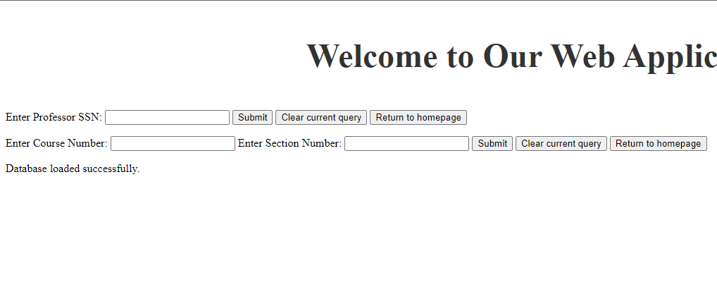

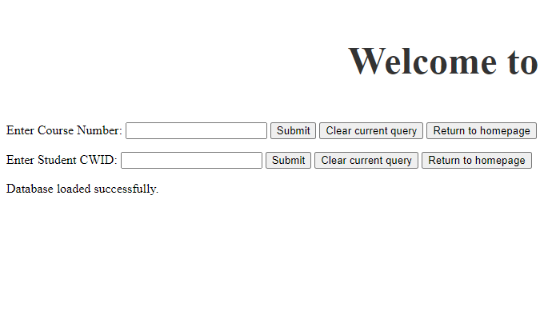

**Student List(use to know what to insert):**

|  |  |  |  |
| --- | --- | --- | --- |
| **CWID** | **Fname** | **Lname** | **D_Num** |
| **103749882** | **Donny** | **Vazquez** | **CPSC** |
| **123358250** | **Hazel** | **Merritt** | **CPSC** |
| **339862886** | **Mary** | **Jones** | **ENGL** |
| **414101389** | **Karen** | **Taylor** | **MATH** |
| **736974249** | **Mark** | **Davis** | **MATH** |
| **796862879** | **Alice** | **Williams** | **CPSC** |
| **932233223** | **Samuel** | **Patton** | **CPSC** |
| **997342361** | **David** | **Lee** | **ENGL** |

**Professor List (use to know what to insert):**

|  |  |
| --- | --- |
| **SSN** | **Name** |
| **123-45-6789** | **Bernie Howell** |
| **234-56-7890** | **Lisa Schaefer** |
| **345-67-8901** | **Renato Archer** |

**Course List (use to know what to insert)**

|  |  |
| --- | --- |
| **Course Number** | **Sections** |
| **CPSC 121** | **Section 01 and Section 02** |
| **CPSC 131** | **Section 01 and Section 02** |
| **ENGL 101** | **Section 01 and Section 02** |
| **MATH 150A** | **Section 01 and Section 02** |

**Picture of Output:**

